Change the questions to (required) in the google form

Id question: make it optional.

1- add a range

2- نغير الصيغة عشان يٌفهم من السؤال انه للدخل العائلي مش الفردي

1. MCQ with "other" option

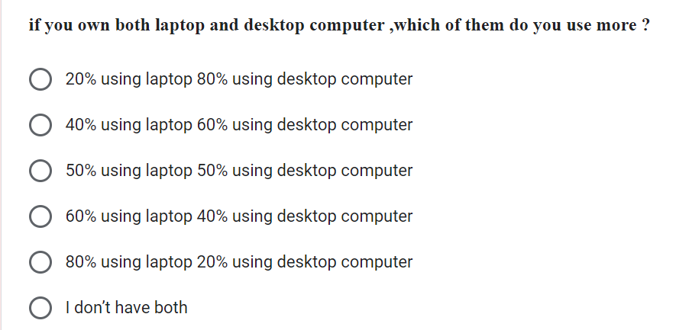

1. Change the choices to (mostly , sometimes , more than ,less than)

1-إضافة خانة للكتابة

2-Add another question about "total" usage, not only the "main usage", and it should be cheek box.

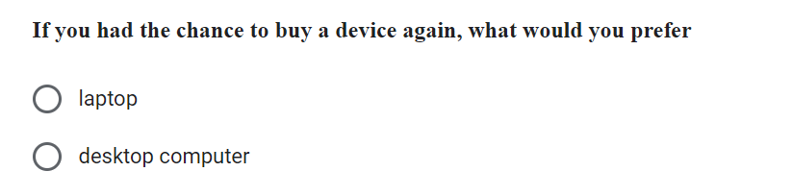add "tablet" in choices.

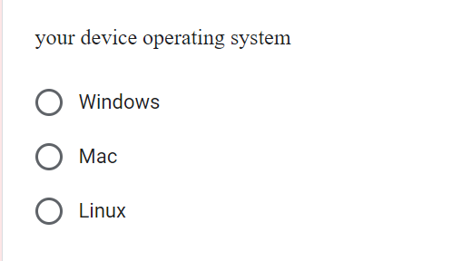 add "other."

change "mostly any game" to "high processing tasks"

1- change the range to (1-5)

1. نغير صيغة السؤال لأنه مش واضح
2. Add storage.

1. Add "hours" word in question to make it clear.
2. Delete the ranges in the question statement.
3. Add a question about "communication"

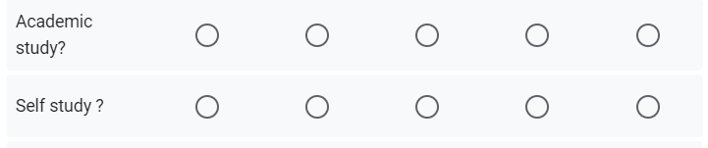

Change it to one question, and change it to "education."

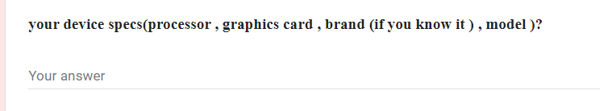

Should be optional.

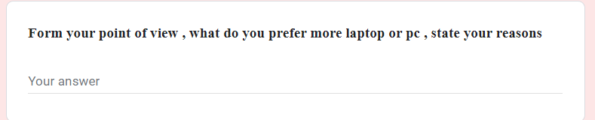

نغير الصيغة